A
PROJECT REPORT ON

collge management system


Guided By
Mr. Milind Anandpara
Submitted in Fulfillment of Requirements
For Completion of Project Work for
Bachelor of Computer Application Semester-5
To
SHASHTRI SWAMI SHREE DHARMAJIVANDASJI INSTITUTE OF INFORMATION TECHNOLOGY
JUNAGADH

Prepared By:
Pithiya Hardik s.
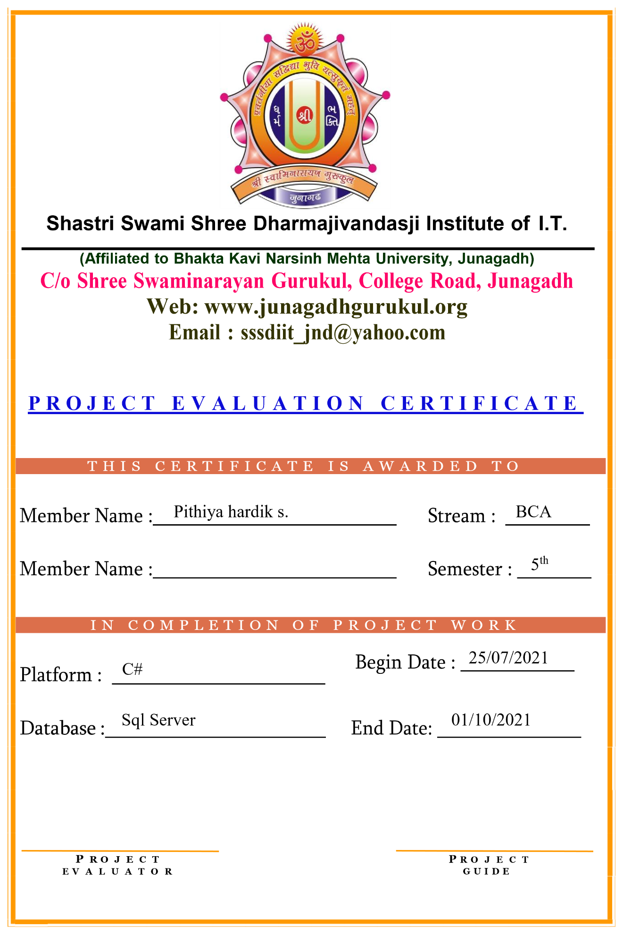
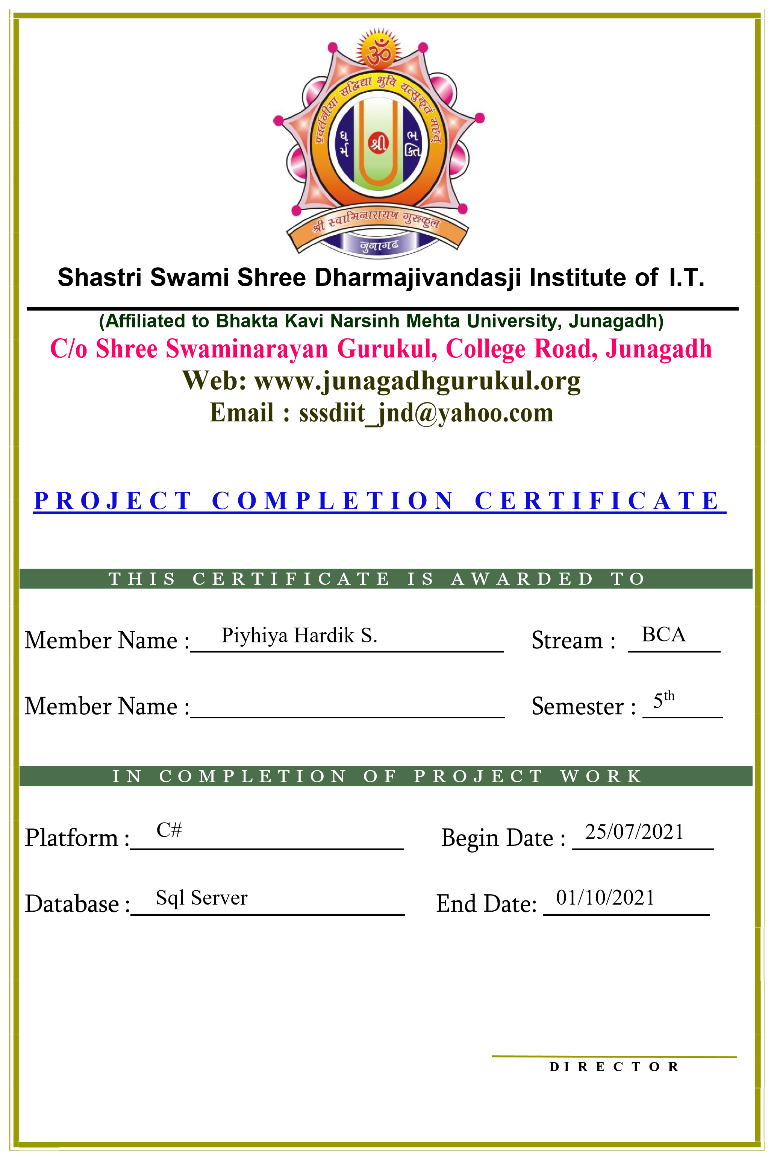
Index

1)Cover and Title page
2) College Certificate
3) Company Certificate [if any]
4) Project Evaluator Certificate
5) Preface
6) Acknowledgement
7) Introduction/Aims and Objective
8)Project Profile
9) System Analysis
10) Project Cost Estimation
11) Identification of Need
11.1 Preliminary Investigation

12) Feasibility Study
12.1 Technical Feasibility
12.2 Economic Feasibility
13.3 Operational Feasibility

13) Project Analysis
13.1 Data Dictionary
13.2 Data Flow Diagrams
13.2.1 DFD 0 Level
13.2.2 DFD 1- Level
13.2.3 DFD 2 Level
13.4 E. R. Diagram

14) S/W Engineering. Paradigm applied[Prototype / Waterfall / Spiral etc.]
15) S/W & H/W Requirement Specification
16) PERTT Chart
17) TIMELINE / GANTT Chart
18) Validation Checks / Special Tool Used / Detailed Project Scope Explanation
19) Testing (Testing techniques and Testing strategies)
20) Implementation and Maintenance
21) All Screen Layouts
22) Future scope of the project / Limitation
23) Bibliography / References / Glossary

PREFACE

Project work is mainly concerned with how we get use of various facilities that are provided by Information Technology to make user’s efforts easier and faster with some extra ordinary facilities.

As we know that BCA is a course on “Computer Application” and it is totally practical field. Only theoretical knowledge is not enough.
In the course of BCA designed by the “Bhakta Kavi Narsinh Mehta University” they have taken full care of this thing and designed the course in such a manner with which student can get theoretical and practical both type of knowledge perfectly.
According to the rules & regulation of “Bhakta Kavi Narsinh Mehta University” in the course of BCA 5 semester we have to create a software project of any organization or industry.

As a BCA students, we have visited Different Web Sites Of Colleges. This project entirely focuses on making different types of Bearings.

In this way we take “College Management System” project on our hand.Our. It is very comfortable and useful for the students.
So, We have tried as our best present this project report in such a way that it makes easy to understand the project work for the

ACKNOWLEDGEMENT

The Presentation of this report gives us the felling of fulfillment.Industrial orientation has bridged the gap between academics and practical real life work for us. It has prepared us to apply ourselves better to become a good professional.
We are very thankful to all , by whose have helped us in preparing this project .We are very happy to represent this “Project Report”. We have an opportunity to express our view.
We like to express our deepest sense of gratitude to our project guiders Mr. Milind Anandpara . Who have always inspired us and directed we towards the successfully complition of our project may be only a dream.
We are very thankful to honorable director of Shashtri Swami Shree Dharmajivandasji Institute of Information Technology Junagadh.
At last but not least, How could we forget the co-operation extended by all the students of BCA(5th sem.) to whom we meet for this project advices.

Yours Faithfully :-
Pithiya Hardik S.

- Introduction and Objective of the Project:

INTODUCTION
- a college management system is a windows application . that use to maintain the record of the student, teacher, student fees, deparement, etc the college is how many student, how many teacher, how many dep. Student fees etc,
- it is a default user name is => admin & password is 123

- Login:
This from is used to login our project and it is required for all users.

- Main:
This is a main from this page is show .the button of all the filleds next page is student user teacher, dep, fees, etc.

- Student
This from is used stored student details and add new student. Edit student details. Delet etc.

- Buttons ->Add New student :
This is a used to add a new student.
- Edit student :
This is a used for the edit the all read added student.

- Delete student:
This is used for a delete record of student

- Teacher:
This from is a used toad new teacher in your collage.
- Button;

- Add teacher:
This is used to add new teacher in your collage
- Edit teacher:

. => Teacher GDU:
This used to a stored and show the details of teacher.
- User:
This is a user page. This is a add new users and access this softer login.
- Default user name is admin and password is 123.
- Used to login in this system.

- Button:-

- Add:
This is used new user Add new user.

- Edit:
Edit user records.

- Delete;
Delete user record

- Department:
This page is used the add. Department details, Etc.
- Button:
- Add:
Add new Dep. In this used

- Delete:
This is used to delete the record of Dep.
- Fees:
This page is used the add student fees in current sem record,
- Button:
- Add:
Add the student submit the fees.

- Edit:
Edit is used the record is edit.
- Delete:
Delete record in this page and database.

- Dash bord:
This page is used t5o show the details of how many student. Teacher Deps,etc.

Project Profile:-
Project Name | College Management System
Develop By | Pithiya Hardik S.
Class | BCA Sem-5
Year | 2021
Front End | C#
Back End | Sql Server
Time Duration
Project Evaluator | Mr. Bittu Khoda
Guided By | Mr. Milind Anandpara
Project Submitted To | Sssdiit-Junagadh

:

System Analysis
- This system is used to student data, teacher data, deparment data, ect store.

- This system is a one admin.

- Admin is login used your user name & password.

- Admin is register new student .

- Admin is all of the used and admin is provide access any one.

- Admin is add new teacher . and edit detels.

- So many use it’s system.

Project Cost Estimation
There are many methods available to get the size of the project. I have use two
Nethods to estimate the size of the project. Those methods are loc (line of
Oae) and fp (function point). With these both methods i can get approximate
Size of the project.

There are two methods available in "Software Engineering" to get the
Approximate cost of the project. These methods are COCOMO (Constructive
Cost Model) and Empirical metlhod. With these both methods I can get
Approximate cost of the project.

T have gone through LOC method to get the approximate size of this software
Project and COCOMO method to gate the approximate cost of the software
Project. Here I have done all the calculations to get the approximate size and
Cost of this website project
Code For | Best | Most likely | Worst
Design | 2000 | 2100 | 2200
Database | 1000 | 1400 | 1500
Coding | 4000 | 4700 | 5000

LOC (23900/3)-8000
KLOC 8000/1000-8
COCOMO METHOD
E-2.4+ (KLOC) 8
2.4+(1.82)8
2.4+14.56
E =16.96 per Month
T-2.5+ (E) 0.38
-2.5+ (1.696) 0.38
T 3.144

Cost estimate is as given blow working time.
3Month-90days
3hr/day-270hours
Expensive & Cot estimation

Computer rent 4000
Light bill 2000
Database design & Creation 1000
Coding 5000
------
Totel 12,000

Then the approximate cost of this software will be about 12,000/- Rs.

Identification of Need
- Preliminary Investigation

A request to receive assistance from information systems can be made
Tor many reasons, but in each case someone nitiates the request When that
Request is made, the first systems activity, the preliminary investigation begins.

I he purpose of the preliminary investigation is to evaluate the project requestss.
It is not a design study, not does it include the collection of details to completely
Describe the business sy stem. Rather, it is the collecting of information that
Permits committee members to evaluate the merits the project request and make
An informed judgment about the feasibility of the proposed project.

I collect the information in this phase through personal interviews.

The following is the questionnaire and the answers of the personal interview
That I taken.
Question 1: Which type of application you want to develop?
Answer: windows application

Question 2: What will the purpose of this software?
Answer: The main purpose of this software will be manage the student data, teacher data, student fees etc.

Question 3: Do you have any this type of running software?
Answer: No, we have no any this type of running software.

Question 4: Tell me about the functionality that you want in your website
Answer: There will be must the following functionality that we need in our
Software.
- Admin login in this software.
- Admin is used all functionality.
- Admin is register student, teacher add deparement detales.
- Admin is show all data .

Question 5: Say something about your website software which must be you want
In your system.
Answer: Design should be simple like there were must be,
- Login page
- Main page
- Student page
- Teacher page
- Dep page
- Etc.

Question 7: What is the budget for your software?
Answer: rs.8000 to rs.10,000

Question 8: How nuch time-duration in you want to complete this website?
Answer: 2 to 3 month.

Question 9 : Please give the title for your software.
Answer: college management system

Question 10: Do you have any logo?
Answer : Yes, we have.

Feasibility Study

Feasibility of a project determines whether it is possible to develop the project
These are four main factors, which determine the feasibility of the project. They
are discussed as follow
- Technical Feasibility:-

The main aim of technical feasibility study is to determine whether it is possible
To develop the proposed system with the present technologies available and
Study the technieal requirements and their availability in the organization & the
Technical equipments availability in market.

So, in this project technical requirement is :

Hardware:- A computer with-
- I GB RAM
- 500 MB Hard disk
- Intel core processor

Software:- Any editor
- Any Browser
- Tomcat Server
- Mysql
The above both technical requirements can be fulfil. So system is technically feasible

- Economical Feasibility:

The economic feasibly takes into consideration the financial matters regarding
the proposed system. The organization measures the cost effectiveness of the
proposed system. The economical feasibility of the proposed system is as under
budget ofa company or not! This is checked in economical feasibility.

As the requirement there is must be the cost of the following things

Development Cost Rs .7000

Light Bill Rs. 2000

Software Rs .2000

Other Rs. 1500
----------------------
Rs.12,500
So, it is also possible.

- 0perational Feasibility:
The operation feasibility deals with the matter whether the proposed system
Fulfills the requirement of the organization. This feasibility determines whether
The proposed system covers all the aspects of the current system & gives an
Extra facility which is not in current system.

As, the requirement there is no any old system or this system can be used by
Any computer basic knowledge person .So, it is also feasible

Project Analysis
- Data Dictionary
Dala Dictionary set of information describing the contents, format, and structure
O a dalabase and the relationship between its clements, used to control access to
and manipulate of the database.

Database :- Collegedb

Table : User Table

Description :- This Table Will Store The User Details.

Field Name | Data type | Constraint | Description
User id | Int | Not null | Store the user id
User name | Varcher | Not null | Store the user name
Password | Varcher | Not null | Store the password

Table :- student table
Description :- this table will be store the student details.

Field name | Data type | Constraint | Description
Student id | Int | Not null | Store the student id
Student name | Varcher(50) | Not null | Store the student name
Student gender | Varcher(50) | Not null | Store the student gender
Student dob | Varcher(50) | Not null | Store the student dob
Student phone | Varcher(50) | Not null | Store the student phone
Student dep | Varcher(50) | Not null | Store the student dep
Student fees | Varcher(50) | Not null | Store the student fees

Table :- teacher table
Description :- this table will be store the teacher details.
Filed name | Data type | Constraint | Description
Teacher id | Int | Not null | Store the teacher id
Teacher name | Varcher(50) | Not null | Store the teacher name
Teacher gender | Varcher(50) | Not null | Store the teacher gender
Teacher dob | Varcher(50) | Not null | Store the teacher dob
Teacher phone | Varcher(50) | Not null | Store the teacher phone
Teacher dep | Varcher(50) | Not null | Store the teacher dep
Teacher address | Varcher(50) | Not null | Store the teacher address

Table :- fees table
Description :- this table will be store the student fees details.
Filed name | Data type | Constraint | Description
Fees num | Int | Not null | Store the fees num
Student id | Int | Not null | Store the student id
Student name | Varcher(50) | Not null | Store the student name
Priod | Varche(50) | Not null | Store the priod
Amount | Int | Not null | Store the amount

Table :- department table
Description :- this table is store the dep information .
Filed name | Data type | Constraint | Description
Dep name | Varcher(50) | Not null | Store the dep name
Dep description | Varcher(500 | Not null | Store the description
Depduration | Varcher(50) | Not null | Store the depduration

Data Flow Diagrams
A data flow diagram (DFD) 1s a graphical representation of the

flow" of the data through an intormation system, modeling its process aspects.
A DFD is often used as a preliminary steps to create an overview of the system
without going into great detail, which can later be elaborated.

DFD is a graphical view of all system processes and transactions. With
she DFD an End-User also can easily understand the system in a short time priod.

Also it is useful to find out problem or any complication with the system we are going to develop we can easy get that whether we have understood the system as per the requirements of the clint or not by showing them this diaggrarm thus dfd id a necessary phase while deueploping.

DfD use number of symbol toIcprosenl nyslem Mosl dala loWdelg
Use lour kinds of symbouthon nYulos ie Ucd lo 1oprcscn lour
kinds of syslom componeniN

1-ProcessCs

2-Datastores

3-DataIlows

4-Extenalenities

CNplanalton of man syabols wlhich aro sed in dala llow dapram I given
below
1)
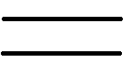 This shape is uscd in data llow diapram lor
rcprescl a paulicular Dalabasc
2)
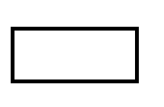 This shape is used in dala Ilow diagram for
Teprescnl a mpul/oulpul procCSS
.
3)
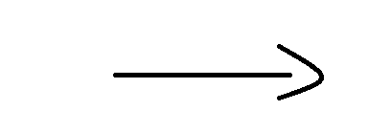 This arow shape is used in data
flow
diagram lor represenl a flow of data
4)
 This shapc is uscd in data llow diagram for
represcnl a particular process

So,the following is the IData Flow Diagram ofmy proyeet

0-.level

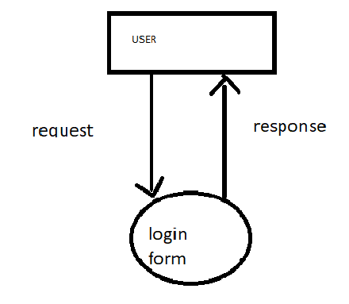

1-level

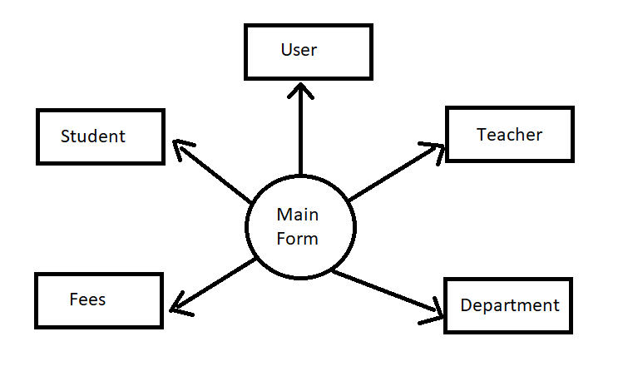

2:-level
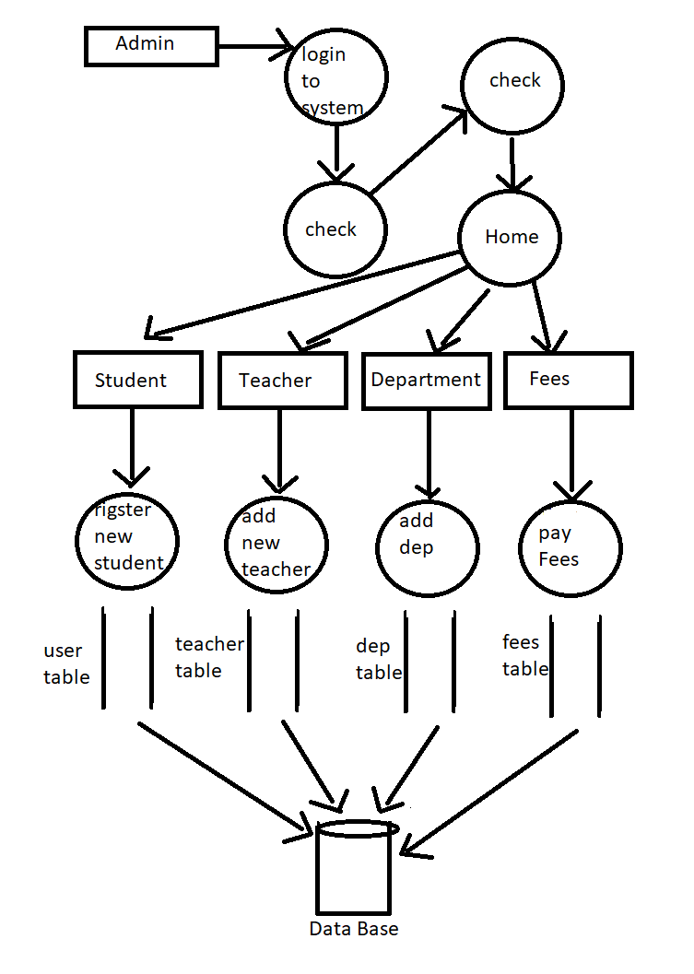
S/W Engineering. Paradigm applied[Prototype / Waterfall / Spiral etc.]

system Development Life Cycle is process of development of software. There
are some steps to follow to create a system.

In sdLc steps follows requirement gathering. In Requirement gathering
estionnaire, personal interview etc. are the method for gathering information.
Analysis phase includes creating Software Reguirement Specification and
nalyze the gathered data. In design phase, design of Software application i.e.
atabase design and GUI design have to be prepared. In coding phase, coding is
aone of different modules and forms. In testing phase, the different type of
esting is done like integration testing, unit testing, system testing and at last the
created website is implemented and maintained.

Following are the different Life Cycle Model example.

- Waterfall model1
- Iterative waterfall model
- Prototyping model
- Evolutionary model
- Spiral model
- R.A.D. model (Rapid Application Development)

am following Waterfall Model following is diagrammatic representation of
different phase of waterfall model.

WATERFALL MODEL
Requirement Gathering and analysis:-
All Possible requirements of the system to be developed are
captured in this phase and documented in a requirement specific doc.

System Design :-
The requirement specification from first phase is studied in this
phase and system design in prepared, system Design helps in defining overall
system architecture

Implementation-
With Inputs from system design the system is first developed in small
programs called nits which are integrated in the next phase, each unit is
developed and tested for its functionality which is referred to as unit testing

Integration and Testing:
All the Units Develops in the Implementation phase are integrated into a
system after testing of each unit post integration the entire system is tested for
any faults and failures

Deployment Ofsystem
Once the functional and non-functional testing is done the product
Is deployed in the customer environment or released into the market

Maintenance
There are some issues which commune in the environment to fix those
ISSue patches are released, also to enhance the product some better version are
released.

WREQUIREMENT SPECIFICATION
- 1 GB Harddisk
- 500 MB RAM
- Monitor
- CPU
- Mouse
SW REQUIREMENTSPECIFICATION
- Windows Operating System
- Mysql server
- C# Editor
- Visual Studio 2012
- With bunfiu framework

PERT Chart
Pert (project Evaluation and Review Technique) charts consist of a network o b
and arrows The boxes represent activities and the arrows represent
hdencies PERT charts are a more sophisticated form of activity chart.
crC 1nstead of making a sngle estimate for each task, pessimistic, likely and
pstC estmates are made The boxes of PERT charts arc usually annotatcd
wh the pessimistic, likely, and optimistic estimates for every task. There are
ol one but many critical paths, depending on the permutations of the
Cstates for cach task This makes analysis of critical path show by using Shaded boxes. The PERT Chart representation of the MIS problem of show follows

GANTTCHART
A Gantt chart is a special type of bar chart where each bar represents an activity.
The bars are drawn along a time line. The length of each bar is proportional to
the duration oftime planned for the coresponding activity
Error! Hyperlink reference not valid.
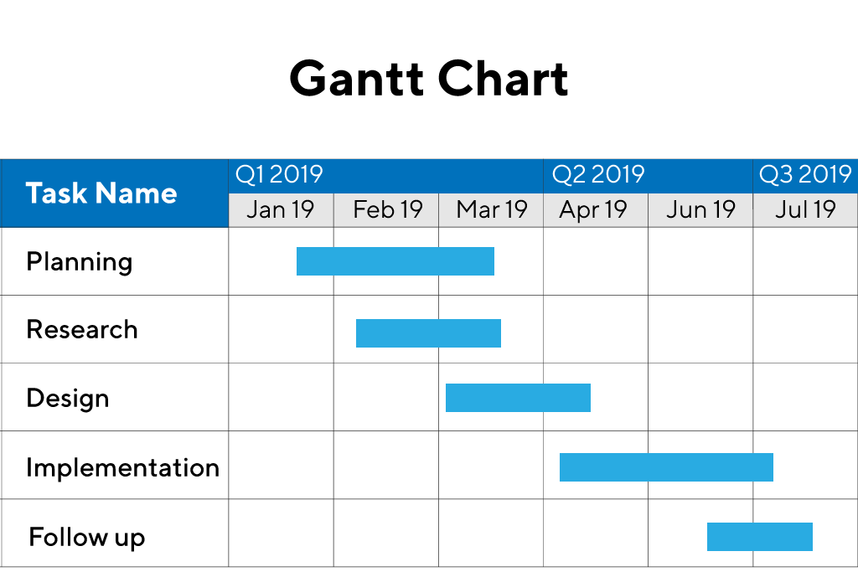

in order to estimate the time durations for various activities. usually managers
let the engineers themselves estimate the time for an activity they might be
assigmed to. However. some managers prefer to estimate the time for varnous
activities themselves. Many managers believe that an aggressive schedule
motivates the engineers to do a job better and faster.
However. careful aspects, but also cause schedule compromise on
intangible quality aspects, but also cause schedule delays. A good way to
achieve accuracy without creating problems is to let people set their own
We can see that one engneer can do the database design and then code
the database design whereas another engineer and design the GUI part, code the
GUI part. and still have time left for writing the user manual. Thus. Gantt charts
are very useful in scheduling resources.

So here, I have to follow the scheduling steps for my project.
Gantt chart is really useful us for planning software application resourcas
Testing (Testing techniques and Testing strategies)

Testing :
There are 3 type of testing following :-

- Black box testing:-
Black Box Testing is a software testing method in which the functionalities of software applications are tested without having knowledge of internal code structure, implementation details and internal paths. Black Box Testing mainly focuses on input and output of software applications and it is entirely based on software requirements and specifications. It is also known as Behavioral Testing.

How to do BlackBox Testing
Here are the generic steps followed to carry out any type of Black Box Testing.
- Initially, the requirements and specifications of the system are examined.
- Tester chooses valid inputs (positive test scenario) to check whether SUT processes them correctly. Also, some invalid inputs (negative test scenario) are chosen to verify that the SUT is able to detect them.
- Tester determines expected outputs for all those inputs.
- Software tester constructs test cases with the selected inputs.
- The test cases are executed.
- Software tester compares the actual outputs with the expected outputs.
- Defects if any are fixed and re-tested.

Types of Black Box Testing
There are many types of Black Box Testing but the following are the prominent ones –
- Functional testing – This black box testing type is related to the functional requirements of a system; it is done by software testers.
- Non-functional testing – This type of black box testing is not related to testing of specific functionality, but non-functional requirements such as performance, scalability, usability.
- Regression testing – Regression Testing is done after code fixes, upgrades or any other system maintenance to check the new code has not affected the existing code.

- White box testing:-
White Box Testing is software testing technique in which internal structure, design and coding of software are tested to verify flow of input-output and to improve design, usability and security. In white box testing, code is visible to testers so it is also called Clear box testing, Open box testing, Transparent box testing, Code-based testing and Glass box testing.

It is one of two parts of the Box Testing approach to software testing. Its counterpart, Blackbox testing, involves testing from an external or end-user type perspective. On the other hand, White box testing in software engineering is based on the inner workings of an application and revolves around internal testing.
The term “WhiteBox” was used because of the see-through box concept. The clear box or WhiteBox name symbolizes the ability to see through the software’s outer shell (or “box”) into its inner workings. Likewise, the “black box” in “Black Box Testing” symbolizes not being able to see the inner workings of the software so that only the end-user experience can be tested.

What do you verify in White Box Testing?
White box testing involves the testing of the software code for the following:
- Internal security holes
- Broken or poorly structured paths in the coding processes
- The flow of specific inputs through the code
- Expected output
- The functionality of conditional loops
- Testing of each statement, object, and function on an individual basis
The testing can be done at system, integration and unit levels of software development. One of the basic goals of whitebox testing is to verify a working flow for an application. It involves testing a series of predefined inputs against expected or desired outputs so that when a specific input does not result in the expected output, you have encountered a bug.
- Grey box testing:-
Grey Box Testing or Gray box testing is a software testing technique to test a software product or application with partial knowledge of internal structure of the application. The purpose of grey box testing is to search and identify the defects due to improper code structure or improper use of applications.
In this process, context-specific errors that are related to web systems are commonly identified. It increases the testing coverage by concentrating on all of the layers of any complex system.
Gray Box Testing is a software testing method, which is a combination of both White Box Testing and Black Box Testing method.
- In White Box testing internal structure (code) is known
- In Black Box testing internal structure (code) is unknown
- In Grey Box Testing internal structure (code) is partially known
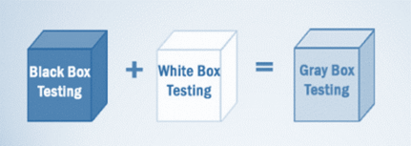
In Software Engineering, Gray Box Testing gives the ability to test both sides of an application, presentation layer as well as the code part. It is primarily useful in Integration Testing and Penetration Testing.

Implementation and Maintenance
- Implementation:-
The software implementation stage involves the transformation of the software technical data package (TDP) into one or more fabricated, integrated, and tested software configuration items that are ready for software acceptance testing. The primary activities of software implementation include the:

Fabrication of software units to satisfy structural unit specifications.

Assembly, integration, and testing of software components into a software configuration item.

Prototyping challenging software components to resolve implementation risks or establish a fabrication proof of concept.

Dry-run acceptance testing procedures to ensure that the procedures are properly delineated and that the software product (software configuration items (CIs and computing environment) is ready for acceptance testing.

- Maintenance:-
Software Maintenance is the process of modifying a software product after it has been delivered to the customer. The main purpose of software maintenance is to modify and update software applications after delivery to correct faults and to improve performance.
Need for Maintenance –
Software Maintenance must be performed in order to:
Attention reader! Don’t stop learning now. Get hold of all the important CS Theory concepts for SDE interviews with the CS Theory Course at a student-friendly price and become industry ready.

- Correct faults.
- Improve the design.
- Implement enhancements.
- Interface with other systems.
- Accommodate programs so that different hardware, software, system features, and telecommunications facilities can be used.
- Migrate legacy software.
- Retire software.

All Screen Layouts & Coding
First Page:-

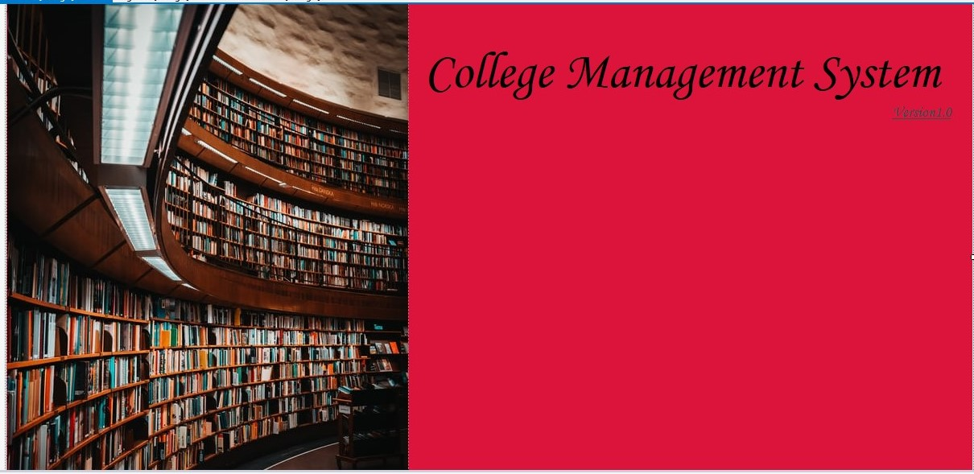

Login form:-

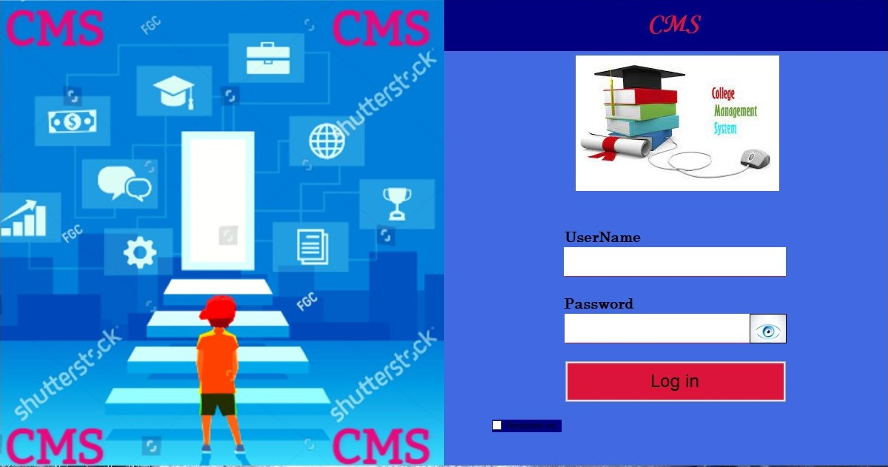

Login form coding:-
using System;
using System.Collections.Generic;
using System.ComponentModel;
using System.Data;
using System.Drawing;
using System.Linq;
using System.Text;
using System.Threading.Tasks;
using System.Windows.Forms;
using System.Data.SqlClient;

namespace College_Management_System
{
public partial class Login : Form
{
public Login()
{
InitializeComponent();
}

SqlConnection con = new SqlConnection(@"Data Source=(LocalDB)\v11.0;AttachDbFilename=C:\Users\ahira\OneDrive\Documents\Collegedb.mdf;Integrated Security=True;Connect Timeout=30");

private void show_Click(object sender, EventArgs e)
{
if (password.PasswordChar == '*')
{
hide.BringToFront();
password.PasswordChar = '\0';
}
}

private void hide_Click(object sender, EventArgs e)
{
if (password.PasswordChar == '\0')
{
show.BringToFront();
password.PasswordChar = '*';
}
}

private void button1_Click(object sender, EventArgs e)
{
MainForm main = new MainForm();

con.Open();
SqlDataAdapter sda = new SqlDataAdapter("select count(*) from UserTable where UserName='"+user.Text+"' and Password='"+password.Text+"'",con);
DataTable dt = new DataTable();
sda.Fill(dt);
if (dt.Rows[0][0].ToString() == "1")
{
main.Show();
this.Hide();
con.Close();
}
else
{
MessageBox.Show("wrong usename and password:");
}
con.Close();
}

}
}

Main form:-

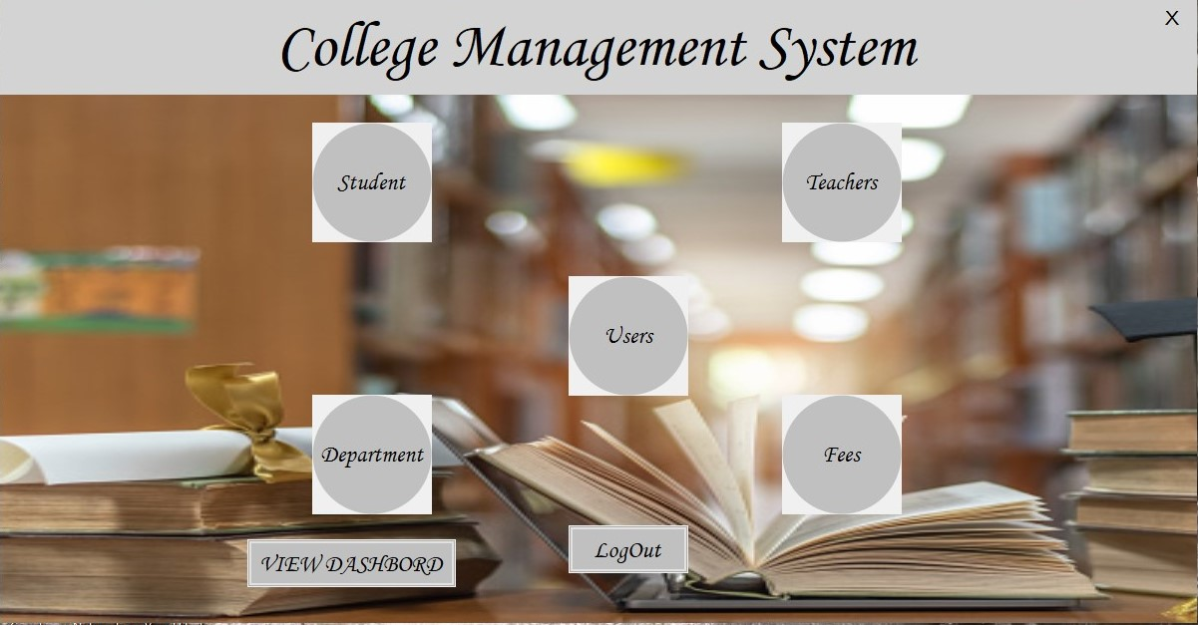

Main form coding:-

namespace College_Management_System
{
public partial class MainForm : Form
{
public MainForm()
{
InitializeComponent();
}

private void fees_Click(object sender, EventArgs e)
{
Fees f = new Fees();
f.Show();
this.Hide();
}

private void student_Click(object sender, EventArgs e)
{
Student s = new Student();
s.Show();
this.Hide();
}

private void teacher_Click(object sender, EventArgs e)
{
Teacher t = new Teacher();
t.Show();
this.Hide();
}

private void user_Click(object sender, EventArgs e)
{
User u = new User();
u.Show();
this.Hide();
}

private void department_Click(object sender, EventArgs e)
{
Department d = new Department();
d.Show();
this.Hide();
}

private void logout_Click(object sender, EventArgs e)
{
Login l = new Login();
l.Show();
this.Hide();
}

private void button1_Click(object sender, EventArgs e)
{
Dashbord d = new Dashbord();
d.Show();
this.Hide();
}

private void label2_Click(object sender, EventArgs e)
{
Application.Exit();
}

}
}

Student form:-

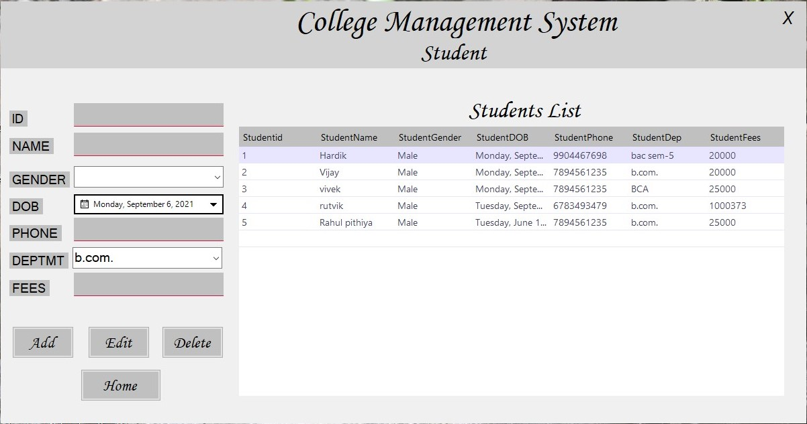

Student form coding:-

namespace College_Management_System
{
public partial class Student : Form
{
public Student()
{
InitializeComponent();
}
SqlConnection con = new SqlConnection(@"Data Source=(LocalDB)\v11.0;AttachDbFilename=C:\Users\ahira\OneDrive\Documents\Collegedb.mdf;Integrated Security=True;Connect Timeout=30");

private void clear()
{
sidtxb.Text = "";
snametxb.Text = "";
sgendercob.Text = "";
sdobdtp.Text = "";
sphonetxb.Text = "";
sdepcob.Text = "";
sfeestxb.Text = "";
}
private void studentdeparementautofull()
{
con.Open();
SqlCommand cmd = new SqlCommand("select DepName from DepartementTable ", con);
SqlDataReader sdr;
sdr = cmd.ExecuteReader();
DataTable dt = new DataTable();
dt.Columns.Add("DepName", typeof(string));
dt.Load(sdr);
sdepcob.ValueMember = "DepName";
sdepcob.DataSource = dt;
con.Close();
}

private void showstu()
{
con.Open();
string query = "select * from StudentTable";
SqlDataAdapter sda = new SqlDataAdapter(query, con);
SqlCommandBuilder bulider = new SqlCommandBuilder(sda);
var ds = new DataSet();
sda.Fill(ds);
studentdgv.DataSource = ds.Tables[0];
con.Close();
}
private void Student_Load(object sender, EventArgs e)
{
showstu();
studentdeparementautofull();
}

private void add_Click(object sender, EventArgs e)
{
try
{
if (sidtxb.Text == "" || snametxb.Text == "" || sgendercob.Text == "" || sdobdtp.Text == "" || sphonetxb.Text == "" || sdepcob.Text == "" || sfeestxb.Text == "")
{
MessageBox.Show("Missing information");
}
else
{
con.Open();
SqlCommand cmd = new SqlCommand("insert into StudentTable values ('" + sidtxb.Text + "','" + snametxb.Text + "','" + sgendercob.SelectedItem.ToString() + "', '"+sdobdtp.Text+"', '"+sphonetxb.Text+"', '"+sdepcob.SelectedValue.ToString()+"', '"+sfeestxb.Text+"')", con);
cmd.ExecuteNonQuery();
MessageBox.Show("User Add successful");
con.Close();
clear();
showstu();
}
}
catch
{
MessageBox.Show(" somthing went wrong");
}
}

private void edit_Click(object sender, EventArgs e)
{
try
{
if (sidtxb.Text == "" || snametxb.Text == "" || sgendercob.Text == "" || sdobdtp.Text == "" || sphonetxb.Text == "" || sdepcob.Text == "" || sfeestxb.Text == "")

{
MessageBox.Show("missing data:");
}
else
{
con.Open();
SqlCommand cmd = new SqlCommand("Update StudentTable set StudentName='" + snametxb.Text + "', StudentGender= '"+sgendercob.SelectedItem.ToString()+"', StudentDOB='"+sdobdtp.Text+"', StudentPhone='"+sphonetxb.Text+"', StudentDep='"+sdepcob.SelectedValue.ToString()+"', StudentFees='"+sfeestxb.Text+"' where StudentId='" + sidtxb.Text + "'", con);
cmd.ExecuteNonQuery();
MessageBox.Show("user edit successfully:");
con.Close();
clear();
showstu();
}
}
catch
{
MessageBox.Show("Somting went wrong user not edit:");
}
}

private void delete_Click(object sender, EventArgs e)
{
try
{
if (sidtxb.Text == "")
{
MessageBox.Show("Enter user id :");
}
else
{
con.Open();
string query = "delete from StudentTable where StudentId ='" + sidtxb.Text + "';";
SqlCommand cmd = new SqlCommand(query, con);
cmd.ExecuteNonQuery();
MessageBox.Show("User delete successfully");
con.Close();
clear();
showstu();
}

}
catch
{
MessageBox.Show("Somting went wrong user not delete: ");
}
}

private void home_Click(object sender, EventArgs e)
{
MainForm m = new MainForm();
m.Show();
this.Hide();
}

private void studentdgv_CellClick(object sender, DataGridViewCellEventArgs e)
{
sidtxb.Text = studentdgv.Rows[e.RowIndex].Cells[0].Value.ToString();
snametxb.Text = studentdgv.Rows[e.RowIndex].Cells[1].Value.ToString();
sgendercob.Text = studentdgv.Rows[e.RowIndex].Cells[2].Value.ToString();
sdobdtp.Text = studentdgv.Rows[e.RowIndex].Cells[3].Value.ToString();
sphonetxb.Text = studentdgv.Rows[e.RowIndex].Cells[4].Value.ToString();
sdepcob.Text = studentdgv.Rows[e.RowIndex].Cells[5].Value.ToString();
sfeestxb.Text = studentdgv.Rows[e.RowIndex].Cells[6].Value.ToString();
}

private void label2_Click(object sender, EventArgs e)
{
this.Close();
MainForm m = new MainForm();
m.ShowDialog();
}
}
}

Teacher form:-

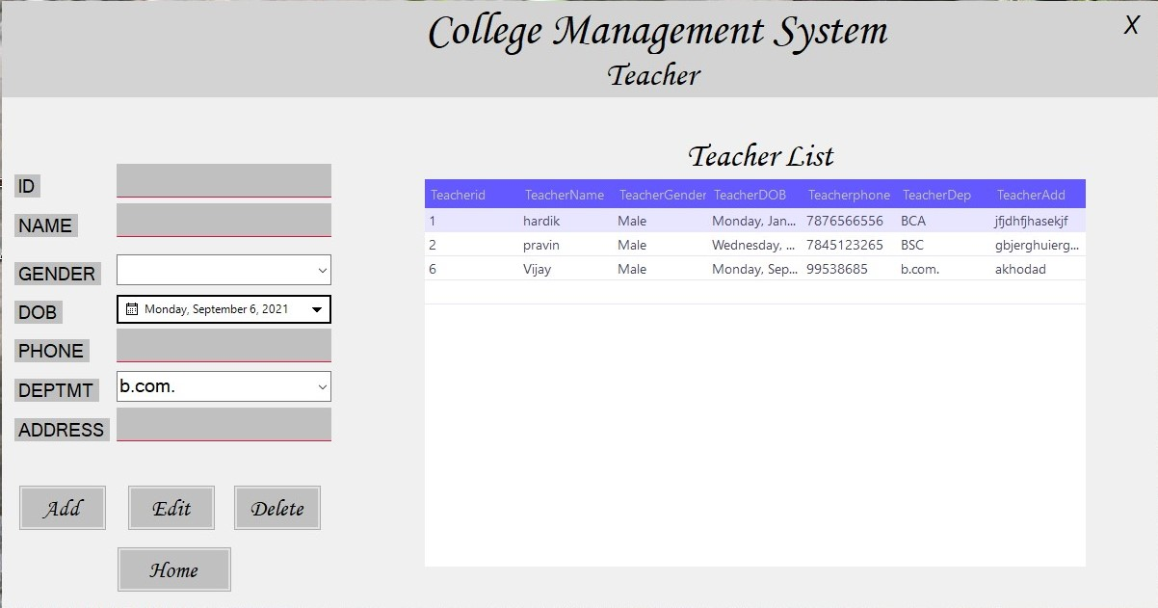

Teacher from coding:-

namespace College_Management_System
{
public partial class Teacher : Form
{
public Teacher()
{
InitializeComponent();
}
SqlConnection con = new SqlConnection (@"Data Source=(LocalDB)\v11.0;AttachDbFilename=C:\Users\ahira\OneDrive\Documents\Collegedb.mdf;Integrated Security=True;Connect Timeout=30");

private void clear()
{
tidtxb.Text = "";
tnametxb.Text = "";
tgendercob.Text = "";
tdobdtp.Text = "";
tphonetxb.Text = "";
taddresstxb.Text = "";
}
private void teacherdeparementautofull()
{
con.Open();
SqlCommand cmd = new SqlCommand("select DepName from DepartementTable ", con);
SqlDataReader sdr;
sdr = cmd.ExecuteReader();
DataTable dt = new DataTable();
dt.Columns.Add("DepName", typeof(string));
dt.Load(sdr);
tdeptmt.ValueMember = "DepName";
tdeptmt.DataSource = dt;
con.Close();
}
private void showteac()
{
con.Open();
string query = "select * from TeacherTable";
SqlDataAdapter sda = new SqlDataAdapter(query, con);
SqlCommandBuilder bulider = new SqlCommandBuilder(sda);
var ds = new DataSet();
sda.Fill(ds);
teacherdgv.DataSource = ds.Tables[0];
con.Close();
}
private void Teacher_Load(object sender, EventArgs e)
{
showteac();
teacherdeparementautofull();
}

private void add_Click(object sender, EventArgs e)
{
try
{
if (tidtxb.Text == "" || tnametxb.Text == "" || tgendercob.Text == "" || tdobdtp.Text == "" || tphonetxb.Text == "" || tdeptmt.Text == "" || taddresstxb.Text == "")
{
MessageBox.Show("Missing information");
}
else
{
con.Open();
SqlCommand cmd = new SqlCommand("insert into TeacherTable values ('" + tidtxb.Text + "','" + tnametxb.Text + "','" + tgendercob.SelectedItem.ToString() + "', '"+tdobdtp.Text+"', '"+tphonetxb.Text+"', '"+tdeptmt.SelectedValue.ToString()+"', '"+taddresstxb.Text+"')", con);
cmd.ExecuteNonQuery();
MessageBox.Show(" Add successful");
con.Close();
clear();
showteac();
}
}
catch
{
MessageBox.Show(" somthing went wrong");
}
}

private void edit_Click(object sender, EventArgs e)
{
try
{
if (tidtxb.Text == "" || tnametxb.Text == "" || tgendercob.Text == "" || tdobdtp.Text == "" || tphonetxb.Text == "" || tdeptmt.Text == "" || taddresstxb.Text == "")
{
MessageBox.Show("missing data:");
}
else
{
con.Open();
SqlCommand cmd = new SqlCommand("Update TeacherTable set TeacherName='" + tnametxb.Text + "',TeacherGender='" + tgendercob.SelectedItem.ToString() + "', TeacherDOB='"+ tdobdtp.Text+"', Teacherphone='"+tphonetxb.Text+"', TeacherDep='"+tdeptmt.SelectedValue.ToString()+"', TeacherAdd='"+taddresstxb.Text+"' where Teacherid='" + tidtxb.Text + "'", con);
cmd.ExecuteNonQuery();
MessageBox.Show(" edit successfully:");
con.Close();
clear();
showteac();
}
}
catch
{
MessageBox.Show("Somting went wrong not edit:");
}
}

private void delete_Click(object sender, EventArgs e)
{
try
{
if (tidtxb.Text == "")
{
MessageBox.Show("Enter teacher id :");
}
else
{
con.Open();
string query = "delete from TeacherTable where Teacherid ='" + tidtxb.Text + "';";
SqlCommand cmd = new SqlCommand(query, con);
cmd.ExecuteNonQuery();
MessageBox.Show(" delete successfully");
con.Close();
showteac();
clear();
}
}
catch
{
MessageBox.Show("Somting went wrong not delete: ");
}
}

private void home_Click(object sender, EventArgs e)
{
MainForm m = new MainForm();
m.Show();
this.Hide();
}

private void teacherdgv_CellClick(object sender, DataGridViewCellEventArgs e)
{
tidtxb.Text = teacherdgv.Rows[e.RowIndex].Cells[0].Value.ToString();
tnametxb.Text = teacherdgv.Rows[e.RowIndex].Cells[1].Value.ToString();
tgendercob.Text = teacherdgv.Rows[e.RowIndex].Cells[2].Value.ToString();
tdobdtp.Text = teacherdgv.Rows[e.RowIndex].Cells[3].Value.ToString();
tphonetxb.Text = teacherdgv.Rows[e.RowIndex].Cells[4].Value.ToString();
tdeptmt.Text = teacherdgv.Rows[e.RowIndex].Cells[5].Value.ToString();
taddresstxb.Text = teacherdgv.Rows[e.RowIndex].Cells[6].Value.ToString();
}

private void label2_Click(object sender, EventArgs e)
{
this.Close();
MainForm m = new MainForm();
m.ShowDialog();
}

}
}

Department form:-

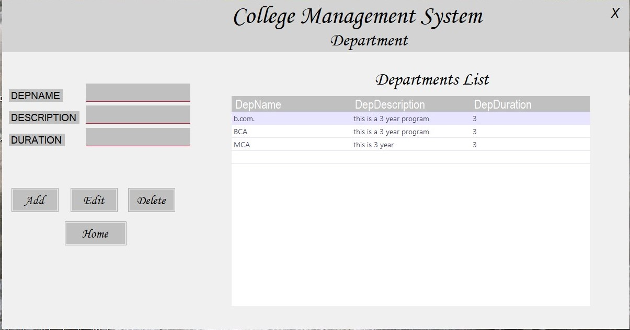

Department form coding:-

namespace College_Management_System
{
public partial class Department : Form
{
public Department()
{
InitializeComponent();
}
SqlConnection con = new SqlConnection(@"Data Source=(LocalDB)\v11.0;AttachDbFilename=C:\Users\ahira\OneDrive\Documents\Collegedb.mdf;Integrated Security=True;Connect Timeout=30");

private void Department_Load(object sender, EventArgs e)
{
show();
}
private void show()
{
con.Open();
string query = "select * from DepartementTable";
SqlDataAdapter sda = new SqlDataAdapter(query, con);
SqlCommandBuilder bulider = new SqlCommandBuilder(sda);
var ds = new DataSet();
sda.Fill(ds);
departmentdgv.DataSource = ds.Tables[0];
con.Close();
}

private void add_Click(object sender, EventArgs e)
{
try
{
if (depnametxb.Text == "" || ddescriptiontxb.Text == "" || dderationtxb.Text == "")
{
MessageBox.Show("Missing information");
}
else
{
con.Open();
SqlCommand cmd = new SqlCommand("insert into DepartementTable values ('" + depnametxb.Text + "','" + ddescriptiontxb.Text + "','" + dderationtxb.Text + "')", con);
cmd.ExecuteNonQuery();
MessageBox.Show(" Add successful");
con.Close();
show();
}
}
catch
{
MessageBox.Show(" somthing went wrong");
}
}

private void edit_Click_1(object sender, EventArgs e)
{
try
{
if (depnametxb.Text == "" || ddescriptiontxb.Text == "" || dderationtxb.Text == "")
{
MessageBox.Show("missing data:");
}
else
{
con.Open();
SqlCommand cmd = new SqlCommand("Update DepartementTable set DepDescription ='" + ddescriptiontxb.Text + "', DepDuration='" + dderationtxb.Text + "' where DepName='" + depnametxb.Text + "'", con);
cmd.ExecuteNonQuery();
MessageBox.Show(" edit successfully:");
con.Close();
show();
}
}
catch
{
MessageBox.Show("Somting went wrong not edit:");
}
}

private void delete_Click_1(object sender, EventArgs e)
{
try
{
if (depnametxb.Text == "")
{
MessageBox.Show("Enter DepName :");
}
else
{
con.Open();
string query = "delete from DepartmentTable where DepName ='" + depnametxb.Text + "';";
SqlCommand cmd = new SqlCommand(query, con);
cmd.ExecuteNonQuery();
MessageBox.Show(" delete successfully");
con.Close();
show();
}

}
catch
{
MessageBox.Show("Somting went wrong not delete: ");
}
}

private void home_Click(object sender, EventArgs e)
{
MainForm m = new MainForm();
m.Show();
this.Hide();
}

private void label2_Click(object sender, EventArgs e)
{
this.Close();
MainForm m = new MainForm();
m.ShowDialog();
}

private void departmentdgv_CellClick_1(object sender, DataGridViewCellEventArgs e)
{
depnametxb.Text = departmentdgv.Rows[e.RowIndex].Cells[0].Value.ToString();
ddescriptiontxb.Text = departmentdgv.Rows[e.RowIndex].Cells[1].Value.ToString();
dderationtxb.Text = departmentdgv.Rows[e.RowIndex].Cells[2].Value.ToString();
}
}
}

Fees form:-

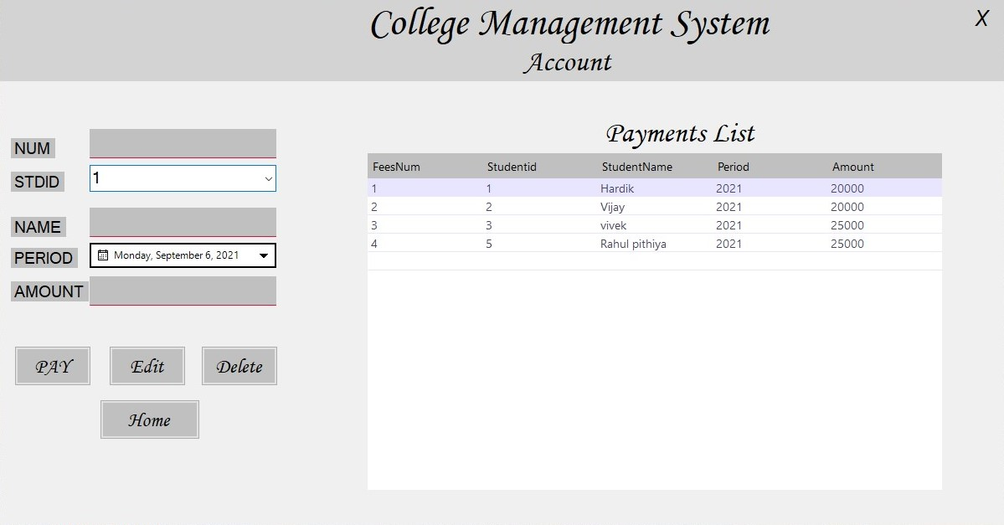

Fees form coding:-

namespace College_Management_System
{
public partial class Fees : Form
{
public Fees()
{
InitializeComponent();
}
SqlConnection con = new SqlConnection(@"Data Source=(LocalDB)\v11.0;AttachDbFilename=C:\Users\ahira\OneDrive\Documents\Collegedb.mdf;Integrated Security=True;Connect Timeout=30");

private void showsfees()
{
con.Open();
string query = "select * from FeesTable";
SqlDataAdapter sda = new SqlDataAdapter(query, con);
SqlCommandBuilder bulider = new SqlCommandBuilder(sda);
var ds = new DataSet();
sda.Fill(ds);
paymentsdgv.DataSource = ds.Tables[0];
con.Close();
}

private void clearf()
{
fnumtxb.Text = "";
fnametxb.Text = "";
famounttxb.Text = "";
}

private void feesdeparementautofull()
{
con.Open();
SqlCommand cmd = new SqlCommand("select Studentid from StudentTable ", con);
SqlDataReader sdr;
sdr = cmd.ExecuteReader();
DataTable dt = new DataTable();
dt.Columns.Add("Studentid", typeof(string));
dt.Load(sdr);
fstdidcob.ValueMember = "Studentid";
fstdidcob.DataSource = dt;
con.Close();
}

private void updatestudent()
{
con.Open();
string query = "Update StudentTable set StudentFees='" + famounttxb.Text + "' where Studentid ='" + fstdidcob.SelectedValue.ToString() + "'";
SqlCommand cmd = new SqlCommand(query,con);
cmd.ExecuteNonQuery();
con.Close();
}

private void Fees_Load(object sender, EventArgs e)
{
showsfees();
feesdeparementautofull();
}

private void fstdidcob_SelectionChangeCommitted(object sender, EventArgs e)
{
con.Open();
string query = "select * from StudentTable where Studentid=" + fstdidcob.SelectedValue.ToString() + "";
SqlCommand cmd = new SqlCommand(query,con);
DataTable dt = new DataTable();
SqlDataAdapter sda = new SqlDataAdapter(cmd);
sda.Fill(dt);
foreach (DataRow dr in dt.Rows)
{
fnametxb.Text = dr["StudentName"].ToString();
}
con.Close();
}

private void pay_Click(object sender, EventArgs e)
{
try
{
if (fnumtxb.Text == "" || fstdidcob.Text == "" || fnametxb.Text == "" || fperiod.Text == "" || famounttxb.Text == "" )
{
MessageBox.Show("Missing information");
}
else
{
string Date = fperiod.Value.Year.ToString();
con.Open();
SqlCommand cmd = new SqlCommand("insert into FeesTable values ('" + fnumtxb.Text + "','" + fstdidcob.SelectedValue.ToString() + "','" + fnametxb.Text + "', '" + Date + "', '" + famounttxb.Text + "')", con);
cmd.ExecuteNonQuery();
MessageBox.Show("Fees Add successful");
con.Close();
updatestudent();
clearf();
showsfees();

}
}
catch
{
MessageBox.Show(" somthing went wrong");
}
}

private void label2_Click(object sender, EventArgs e)
{
this.Close();
MainForm m = new MainForm();
m.ShowDialog();
}

private void home_Click(object sender, EventArgs e)
{
MainForm m = new MainForm();
m.Show();
this.Hide();
}

private void paymentsdgv_CellClick(object sender, DataGridViewCellEventArgs e)
{
fnumtxb.Text = paymentsdgv.Rows[e.RowIndex].Cells[0].Value.ToString();
fstdidcob.Text = paymentsdgv.Rows[e.RowIndex].Cells[1].Value.ToString();
fnametxb.Text = paymentsdgv.Rows[e.RowIndex].Cells[2].Value.ToString();
fperiod.Text = paymentsdgv.Rows[e.RowIndex].Cells[3].Value.ToString();
famounttxb.Text = paymentsdgv.Rows[e.RowIndex].Cells[4].Value.ToString();
}

private void delete_Click(object sender, EventArgs e)
{
try
{
if (fnumtxb.Text == "")
{
MessageBox.Show("Enter num id :");
}
else
{
con.Open();
string query = "delete from FeesTable where FeesNum ='" + fnumtxb.Text + "';";
SqlCommand cmd = new SqlCommand(query, con);
cmd.ExecuteNonQuery();
MessageBox.Show(" delete successfully");
con.Close();
clearf();
showsfees();
}

}
catch
{
MessageBox.Show("Somting went wrong user not delete: ");
}
}

private void edit_Click(object sender, EventArgs e)
{
try
{
if ( fnumtxb.Text == "" || fnametxb.Text == "" || fstdidcob.Text == "" || fperiod.Text == "" || famounttxb.Text == "" )
{
MessageBox.Show("missing data:");
}
else
{
con.Open();
string Date = fperiod.Value.Year.ToString();
SqlCommand cmd = new SqlCommand("Update FeesTable set Studentid='" + fstdidcob.SelectedValue.ToString() + "', StudentName= '" + fnametxb.Text + "', Period ='" + Date + "', Amount='" + famounttxb.Text + "' where FeesNum='" + fnumtxb.Text + "'", con);
cmd.ExecuteNonQuery();
MessageBox.Show(" edit successfully:");
con.Close();
updatestudent();
clearf();
showsfees();
}
}
catch
{
MessageBox.Show("Somting went wrong not edit:");
}
}

}
}

Dashbord foem:-

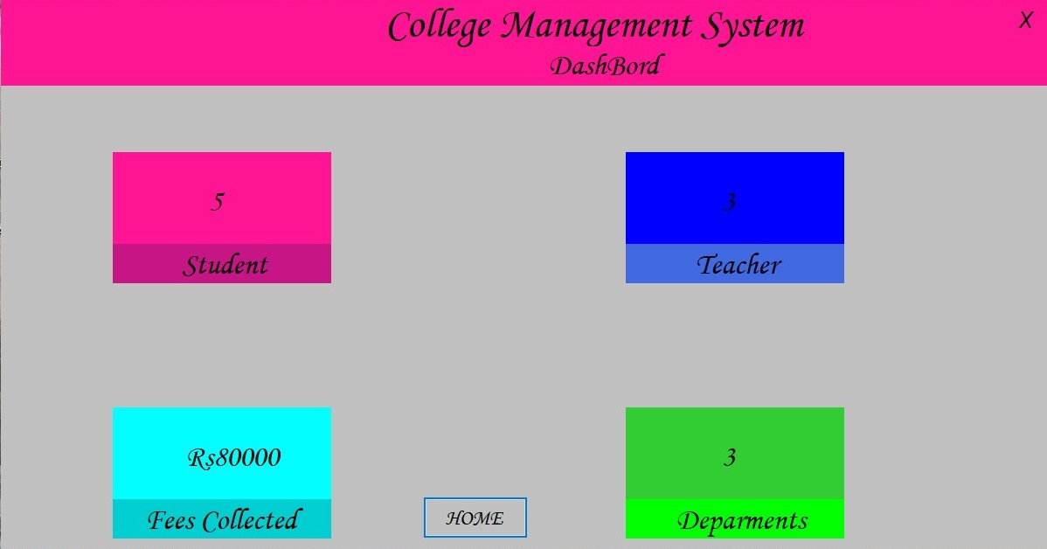

Deshbord coding:-

amespace College_Management_System
{
public partial class Dashbord : Form
{
public Dashbord()
{
InitializeComponent();
}

SqlConnection con = new SqlConnection(@"Data Source=(LocalDB)\v11.0;AttachDbFilename=C:\Users\ahira\OneDrive\Documents\Collegedb.mdf;Integrated Security=True;Connect Timeout=30");

private void Dashbord_Load(object sender, EventArgs e)
{
con.Open();
SqlDataAdapter sda1 = new SqlDataAdapter("select count(*) from StudentTable ", con);
DataTable dt1 = new DataTable();
sda1.Fill(dt1);
stulab.Text = dt1.Rows[0][0].ToString();

SqlDataAdapter sda2 = new SqlDataAdapter("select count(*) from FeesTable ", con);
DataTable dt2 = new DataTable();
sda2.Fill(dt2);
feeslab.Text ="Rs" +Convert.ToInt32(dt2.Rows[0][0].ToString())*20000;

SqlDataAdapter sda3 = new SqlDataAdapter("select count(*) from TeacherTable ", con);
DataTable dt3 = new DataTable();
sda3.Fill(dt3);
teaclab.Text = dt3.Rows[0][0].ToString();

SqlDataAdapter sda4 = new SqlDataAdapter("select count(*) from DepartementTable ", con);
DataTable dt4 = new DataTable();
sda4.Fill(dt4);
deplab.Text = dt4.Rows[0][0].ToString();

con.Close();
}

private void label2_Click(object sender, EventArgs e)
{
this.Close();
MainForm m = new MainForm();
m.ShowDialog();

}

private void logout_Click(object sender, EventArgs e)
{
MainForm m = new MainForm();
m.Show();
this.Hide();
}

}
}

Future scope of the project / Limitation

the future scope of this system is following:-

- I can develop ui better then now
- I can implement a student attendance
- I can add many more facility
- Student show your attendance
- Student show your marks for test
- I can make a website to used some facility

BIBLIOGRAPHY
There are some study materials which is used by me to develop my
project which are as below :

websites:-
- W3c school
- gees for geeks
books:-

c#
c# referral book

